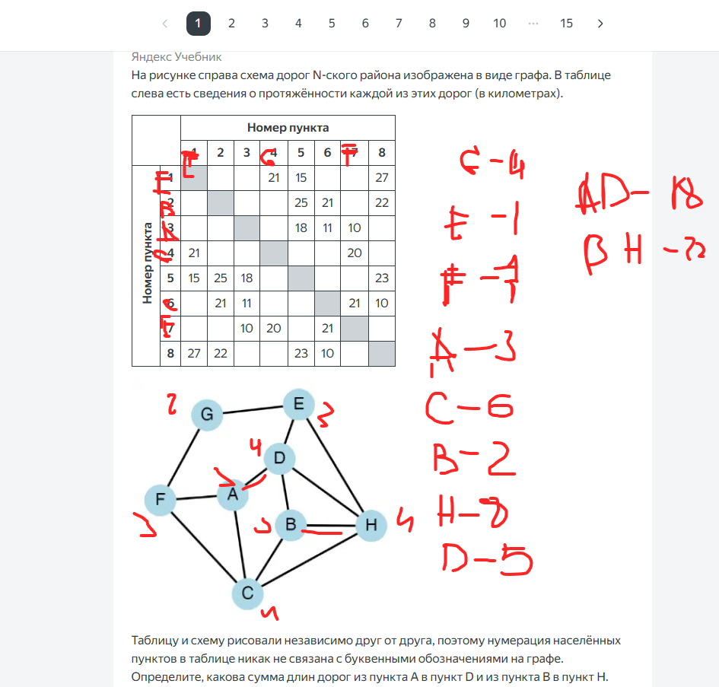

|  |  |  |  |  |
| --- | --- | --- | --- | --- |
| x | y | w | z | f |
| 0 | 0 | 0 | 1 | False |
| 0 | 1 | 0 | 1 | False |
| 0 | 1 | 1 | 1 | False |

| **z** | **y** | **w** | **x** | **F** |
| --- | --- | --- | --- | --- |
| **1** | 1 | 1 | 0 | **0** |
| **1** | 0 | 0 | 0 | **0** |
| **1** | 1 | 0 | 0 | **0** |

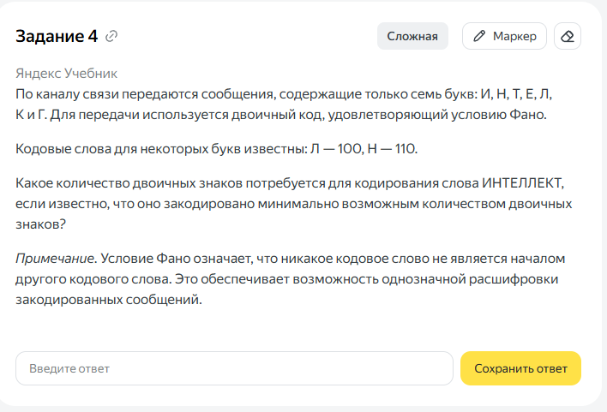

|  |  |  |  |  |  |  |  |  |  |  |
| --- | --- | --- | --- | --- | --- | --- | --- | --- | --- | --- |
|  | Буква | Код | Частота | итог | Код | Частота | итог | Код | Частота | итог |
|  | И | 101 | 1 | 3 | 1110 | 1 | 4 | 101 | 1 | 3 |
|  | Н | 110 | 1 | 3 | 110 | 1 | 3 | 110 | 1 | 3 |
|  | Т | 01 | 2 | 4 | 0 | 2 | 2 | 00 | 2 | 4 |
|  | Е | 111 | 2 | 6 | 101 | 2 | 6 | 01 | 2 | 4 |
|  | Л | 100 | 2 | 6 | 100 | 2 | 6 | 100 | 2 | 6 |
|  | К | 000 | 1 | 3 | 11110 | 1 | 5 | 1110 | 1 | 5 |
|  | Г | 001 | 0 | 0 | 11111 | 0 | 0 | 1111 | 0 | 0 |
|  |  |  |  | 25 |  |  | 26 |  |  | 25 |

|  |  |  |  |  |  |  |  |  |  |  |
| --- | --- | --- | --- | --- | --- | --- | --- | --- | --- | --- |
|  | Буква | Код | Частота | итог | Код | Частота | итог | Код | Частота | итог |
|  | И | 011 | 1 | 3 | 1110 | 1 | 4 | 101 | 1 | 3 |
|  | Н | 110 | 1 | 3 | 110 | 1 | 3 | 110 | 1 | 3 |
|  | Т | 00 | 2 | 4 | 0 | 2 | 2 | 00 | 2 | 4 |
|  | Е | 101 | 2 | 6 | 101 | 2 | 6 | 01 | 2 | 4 |
|  | Л | 100 | 2 | 6 | 100 | 2 | 6 | 100 | 2 | 6 |
|  | К | 111 | 1 | 3 | 11110 | 1 | 5 | 1110 | 1 | 5 |
|  | Г | 010 | 0 | 0 | 11111 | 0 | 0 | 1111 | 0 | 0 |
|  |  |  |  | 25 |  |  | 26 |  |  | 25 |

